**EXPERIMENT -6**

**(BY: AMAN TYAGI)**

**AIM:** Understanding Docker File and pushing to Docker hub.

1. Making and building a docker file

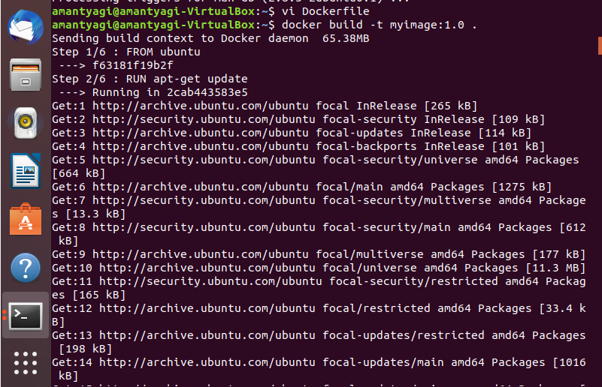

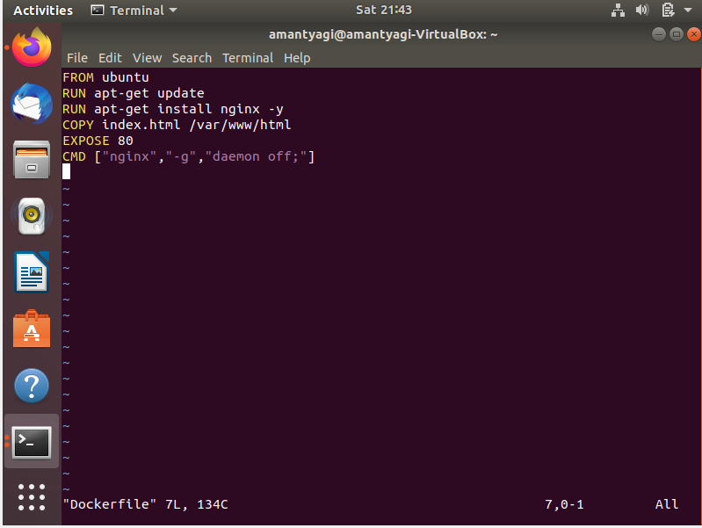

2. Making of Index.html and again building dockerfile

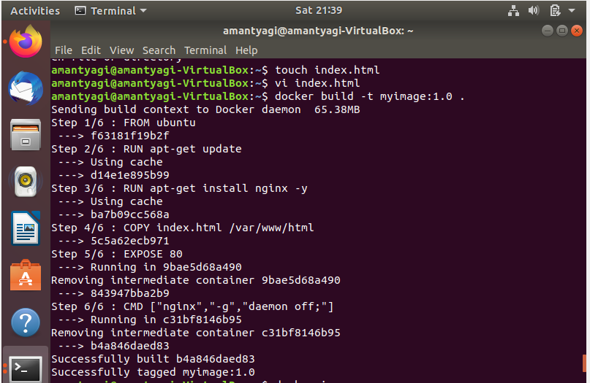

3. Checking image we created

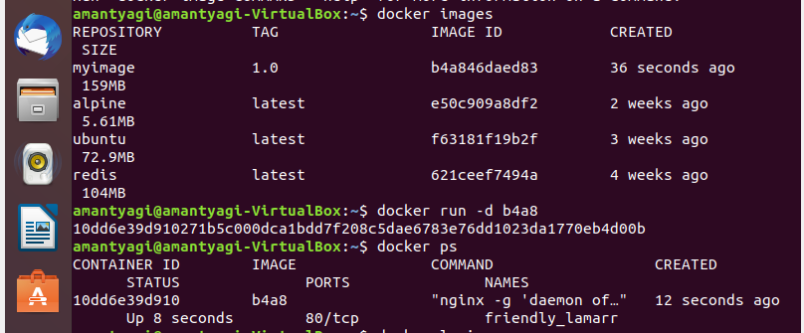

4. Login to Docker hub and creating a tag

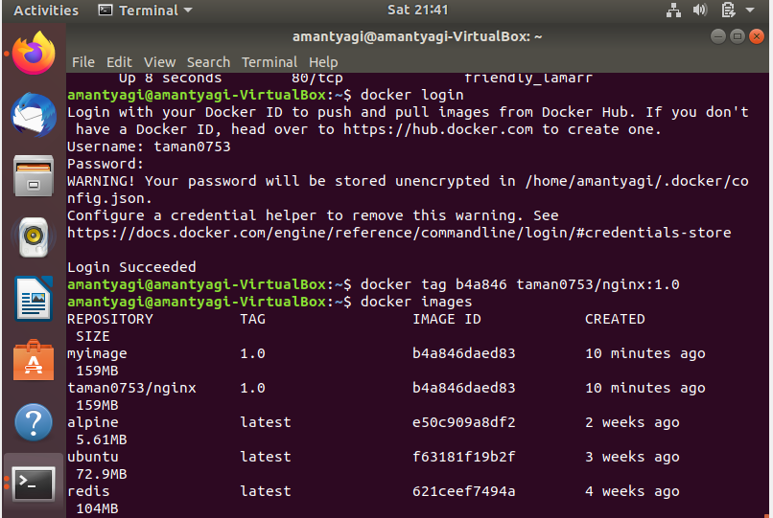

5. Pushing to docker hub

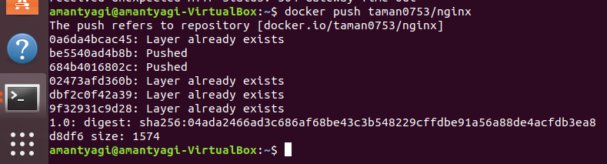

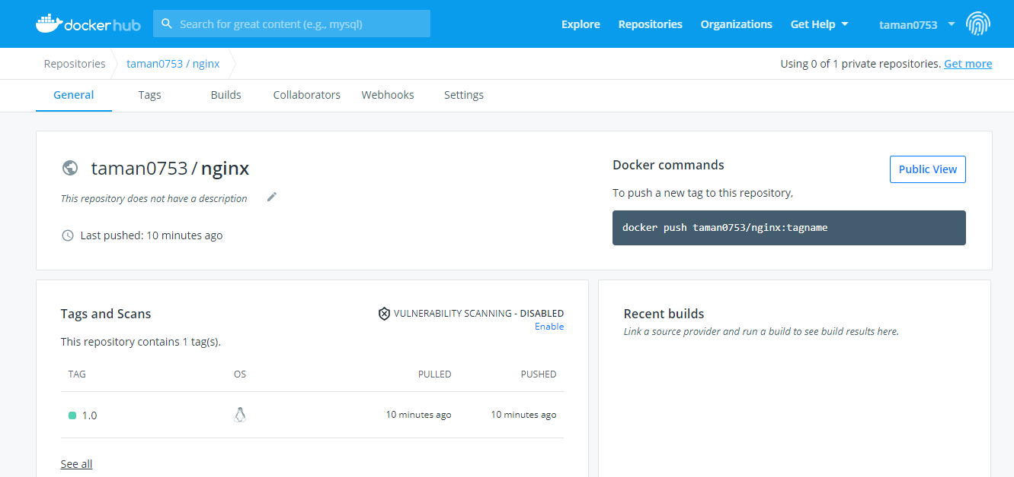

6. Pulling from docker hub

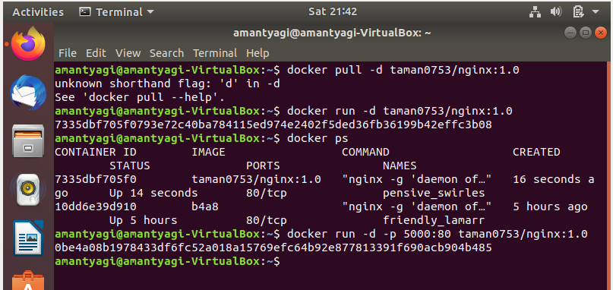

7. Viewing the webpage on localhost

